**IOT-BASED FIRE DETECTION PROTOTYPE(FiDo) USING NAIVE BAYES METHOD**

**Si Made Angga Dwitya P1, Mohamad Nurkamal Fauzan2, Syafrial Fachri Pane3, Noviana Riza4**

1,2,3,4Department of Informatics, Politeknik Pos Indonesia

|  |  |  |
| --- | --- | --- |
| **Article Info** |  | **ABSTRACT** |
| ***Article history:***  Received  Revised  Accepted  Pubilshed |  | Fires often occur in residential areas, public facilities, offices or in the forest. The emergence of fires itself often leaves a lot of casualties. In the fire detection equipment on the market today, using a working principle that only uses 2 detectors, namely smoke and temperature. But these tools cannot determine the condition of a room in a safe or dangerous condition.  Therefore a FiDo fire detector prototype was made in order to know the condition of a room in a safe or dangerous condition. This tool uses smoke, fire, and temperature sensors as detectors and as data in determining the condition of a room. This tool is also equipped with a notification feature to the user and a water spray mechanism when a fire is detected. This study uses the Naïve Bayes method for the condition or status of a room in a safe or dangerous condition. This method was chosen because it is a fairly good classification method in which the classification class has been determined from the start. The purpose of this research is to make a tool that can detect fires and provide information about the conditions of a room. The results of this study are that the FiDo fire detection prototype was tested to produce an accuracy rate of 89%. |
| ***Keywords:***  Fires  Fire Sensor  Temperature Sensor  Smoke Sensor  Naïve Bayes |
|  |
| ***Corresponding Author:***  Si Made Angga Dwitya P,  Department of Informatics,  Politeknik Pos Indonesia,  Jl. Sari Asih No.54, Sarijadi, Kec. Sukasari, Kota Bandung, Jawa Barat 40151  Email: anggadwitya428@gmail.com | | |

1. **INTRODUCTION**

Indonesia is the 4th most populous country in the world after China, India and the United States. According to the National Development Planning Agency, Indonesia's population from 2015 to 2020 amounted to 255,461,700 people with a population growth rate of 1.19. [1] With the increasing population, the primary needs in the form of housing in each individual community will increase as well and this can lead to a densely populated settlement that makes houses between other houses coincide. [2] One of the problems experienced in a densely populated settlement is a fire disaster.

With the very rapid development of technology, fire detection devices have been sold in the market. In fire detection devices on the market today, using a working principle that only uses 2 detectors, namely temperature and smoke. In addition, there is a warning sound and a water spraying mechanism with a pre-designed pipeline. [3] But these tools cannot determine the condition of a room in a safe or dangerous condition.

To solve this problem, in this study a fire detection prototype (FiDo) based on IoT was made using themethod Naïve Bayes. The sensors used are fire and smoke sensors as sensors to detect fire.

The application of IoT in this research uses telegram to notify users. The fire sensor is a sensor that has a function to detect the flame, while the smoke sensor is a sensor that is used to determine the surrounding smoke conditions. The temperature sensor is also used to detect the temperature of an object. [4] Sensors for fire, temperature, and smoke are useful for supporting fire detection.

In its application, the Bayes rule assumes that each attribute has strong independence, meaning that each value on an attribute is not related to the presence of the same value or not with other attributes in the same data. [5] In this research, this method is used to classify the condition or status of a room in a safe or dangerous

condition. or the status of a room in a safe or dangerous condition. Thus, with this research, fire detection is increasingly accurate and deficiencies in the previous tools can be overcome.

1. **METHOD**

This study uses a Naïve Bayes method. This method consists of several stages. The flow of the research process can be seen in Figure 1

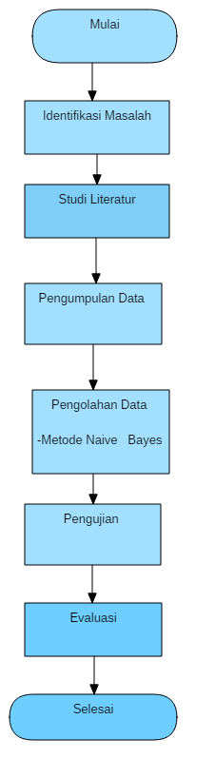

Figure 1. Context Diagram

* 1. **Problem Identification**

Objective: To identify problems in classifying the condition or status of a room before and after a fire.

Method of collecting data.

Input: Secondary Data.

Output: Formulation of the problem according to existing data.

* 1. **Literature Study**

At this stage, studying data and information about fire detection and the Naïve Bayes method is used to classify the condition or status of a room before and after a fire. In this study, references were taken from various sources of journals and books.

* 1. **Data Collection**

Purpose: To identify problems in classifying the condition or status of a room before and after a fire.

Input: Primary data.

Methods: Data collection techniques are primary data.

Output: fire sensor, temperature sensor, smoke sensor and camera ready for processing.

Data collection is carried out to obtain information needed to achieve research objectives. In this study using data sources, namely primary data. Primary data sources are data that are directly collected by researchers from existing sources.

Table 1. Experiment Data

|  |  |  |  |  |
| --- | --- | --- | --- | --- |
| Suhu | Api | Asap | Kamera | Kondisi Ruangan |
| Suhu Ruangan | Tidak ada api | Tidak ada Asap | Bukan api | Aman |
| Sedang | ada api | sedang | Api | Bahaya |
| Tinggi | Tidak ada api | Tinggi | Bukan api | Bahaya |
| Suhu Ruangan | ada api | Tidak ada Asap | api | Aman |
| Sedang | Tidak ada api | sedang | Bukan api | Aman |
| Tinggi | ada api | Tinggi | api | Bahaya |
| Suhu Ruangan | Tidak ada api | sedang | Bukan api | Aman |
| Sedang | ada api | Tinggi | api | Bahaya |
| Tinggi | Tidak ada api | sedang | Bukan api | Bahaya |

* 1. **Data processing**

Objective: Processing the collected

data Input: Primary data

Method: Naïve Bayes method

Output: The data is processed using the Naïve Bayes method.

At this stage, the researcher will process the data from the previously obtained data using the Naïve Bayes method.

* + 1. **Naïve Bayes**

Naïve Bayes is a method to classify using simple and basic chance prediction techniques. Naive Bayes for each decision class, calculates the probability on the condition that the decision class is declared true, given the object's information vector. The process in calculating the naïve Bayes method:

1. Calculating the total probability of each class of events

$$P\left(Ci\right)$$

The first step that needs to be done is to calculate the total probability of each class of events. The trick is to divide the number of event class data by the number of all data in the table.

The formula:

1. Compute the detailed probability of the variable in the class

The second stage is to calculate the probability of each case. The calculation is done by counting the number of cases that occur in each variable, in accordance with the additional data, with each class of events.

Formula:

$$P(X|Ci)$$

1. Multiplying all class variables

The third stage is to multiply all the resulting variables in each class of events. For the example above, the calculations are as follows:

Formula**:**

$$P(X|Ci)*P(Ci)$$

1. Comparing the results between classes

In this final stage, all that needs to be done is to compare the final results of the existing classes. The result or decision taken is the greatest result.

* 1. **Testing**

Objectives: Testing the results of data processing using the Naïve Bayes Method

Input: Primary Data

Method: Naïve Bayes Method

Output: Getting the test results from data processing

The researcher will test the results of the data that has been processed using the Naïvemethod. So that it provides an output in the form of a prediction of the condition of a room in a safe or dangerous condition.

* 1. **Evaluation**

Objective: Test the results of data processing using the Naïve Bayes Method

Input: Secondary Data

Method: Naïve Bayes Method

Output: Obtain test results from data processing.

Get results whether the Naïve Bayes method is good at determining the conditions of a room in safe or dangerous conditions.

1. **RESULTS AND DISCUSSION**

In building a FiDo fire detection prototype for fire detection, a design is needed. The design of this prototype is intended so that the formation of the system can produce a prototype that functions efficiently and optimally

**3.1. System Workflow**

The system analysis to be built will be described in detail in the flowchart following:

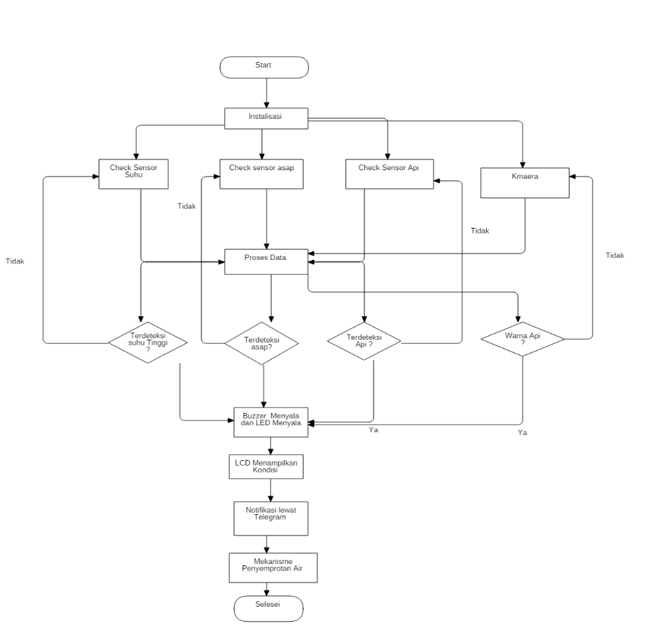

Figure 2. Prototype FiDo FlowChart

**3.2. Result**

After the above process is complete, the testing phase is carried out to check whether the tool is as expected or not. In this stage the experiment will be carried out by lighting a fire near the fire detector and observing the changes that occur. From the test results, it will be determined whether the tool requires repair or not. After that, the data was collected

**3.2.1 Results of the application of the Naïve Bayes Method on the Tool**

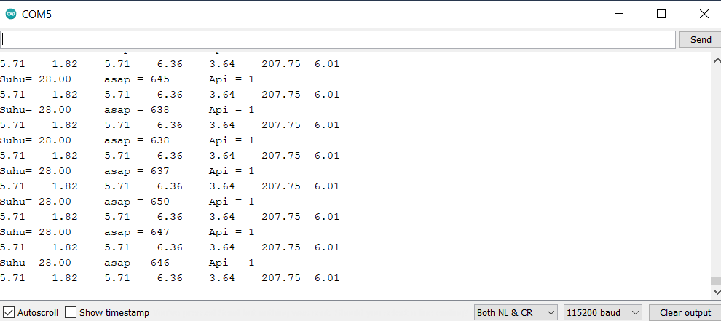

Figure 3. Results of the Application of the Naïve Bayes Method in the Tool

Picture above is a display of the results of the application of the naïve bayes method on a device that is monitored via the Arduino IDE.

**3.2.2 Output Condition if there is no fire**

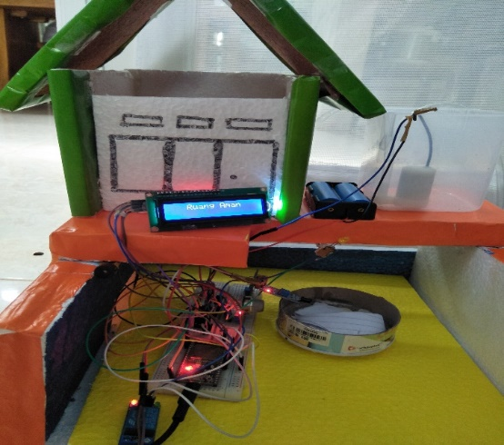

Figure 4. Output Condition if there is no fire

The Image above is a display of the condition if there is no fire where the LCD will say that the room is safe

**3.2.3 Output Current Conditions Fire Occurred**

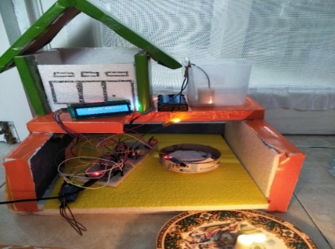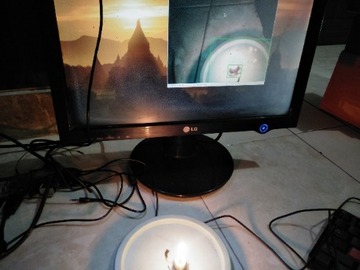

Figure 5. Output Current Conditions Fire Occurred

Pictured above is a view of the conditions in case of fire where the LEDs and buzzer lit simultaneously. The LCD will say that the room is dangerous depending on the conditions of the room. The camera here is also used to detect fire in the event of a fire,

**3.2.4 Notification Output on Telegram**



Figure 6. Notification Output on Telegram

The image above is a notification display to the user via telegram when conditions are safe and conditions of fire (Danger)

**3.2.5 Overall Tool Results**

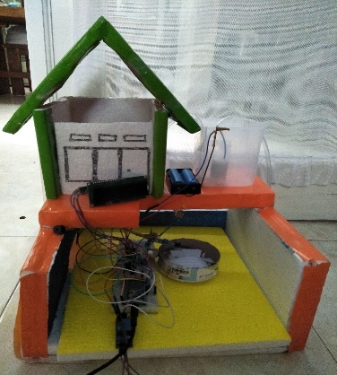

Figure 6. Overall Tool Results

The picture above is a display of the entire fire detection prototype.

1. **CONCLUSION (10 PT)**

Based on the research conducted, the conclusions obtained are:

1. The application of the Naïve Bayes method to the FiDo fire detection prototype is used to determine the condition of a room.
2. The application of IoT to the FiDo fire detection prototype using telegram as a medium for providing information to users.
3. 3. This tool successfully applies the naïve Bayes method to determine the condition of a room which is classified into 2, namely hazardous conditions and safe conditions
4. The accuracy of the naïve Bayes method produced is 89%
5. results of the tests carried out the author can conclude that the 5.From theprototype FiDo Thiscan detect fires. Then theindicator LEDlights up and the buzzer sounds when there is a fire. In addition, the LCD also notifies the condition of the room. Furthermore, this tool will send notifications to users via telegram and be accompanied by a water spraying mechanism in the event of a fire
6. **REFERENCES**

[1] K. N. K. Hariyawati And D. A. Pratika, "Rancang Bangun Prototipe Pendeteksi Kebakaran Menggunakan Konsep Internet-Of-Things," Jurnal Teknik: Media Pengembangan Ilmu Dan Aplikasi Teknik , Vol. 18, No. 1, Pp. 17-26 , 2019.

[2] P. G. Candra, A. Qustoniyah And D. U. Effendy, "Prototipe Sistem Pemadam Kebakaran Otomatis Berbasis Mikrokontroller Avr Atmega16 Menggunakan Sensor Api Dan Sensor Asap," Conference On Innovation And Application Of Science And Technology, Vol. 1, No. 1, Pp. 676-685, 2018

[3] A. M. Firdaus, D. Syauqy And R. Maulana, "Sistem Deteksi Titik Kebakaran Dengan Algoritme K-Nearest Neighbor Menggunakan Sensor Asap Dan Sensor Api," Jurnal Pengembangan Teknologi Informasi Dan Ilmu Komputer, Vol. 3, No. 9, Pp. 8656-8663, 2019

[4] N. Jamal And S. , "Monitoring Keamanan Ruangberbasis Arduino Dan Dan Android menggunakan Kamera Vc0706 Dan Sensor Asap Dht-11," Jurnal Skanika, Vol. 1, No. 3, Pp. 1219-1224, 2018

[5] S. Mulyati And S. , "Internet Of Things (Iot) Pada Prototipe Pendeteksi Kebocoran Gas Berbasis Mq-2 Dan Sim800l," Jurnal Teknik: Universitas Muhammadiyah Tangerang, Vol. 7, No. 2, Pp. 64-72 , 2018